Realistic Rendering of Stars in the Bright Star Catalog using a custom Stereographic Projection

1.0 Introduction

2.0 Literature Review

3.0 Research Methodology

3.1 Dataset Creation

The creation of the star dataset involved a meticulous process of data acquisition, merging, and transformation, resulting in a comprehensive astronomical resource. This report outlines the key steps taken in assembling and enhancing this dataset, highlighting the technical methods and tools employed.

3.1.1 Data Sources and Initial Preparation
1. Bright Star Catalog Acquisition:
- Source: The initial dataset was sourced from the Bright Star Catalog available at CDS Strasbourg.
- Format Conversion: The raw data was saved as a CSV file to enhance readability and facilitate data manipulation.
2. Data Selection from Bright Star Catalog:
- Columns Extracted: Key columns such as 'hr', 'name', 'hd', 'rahrs', 'ramin', 'rasec', 'dec-', 'decdeg', 'decmin', 'decsec', 'GLON', 'Parallax' and 'GLAT' were selected to form a new dataset. This step involved basic copying and pasting operations.
- The Parallax column was renamed to plx to match that of the main hipparcos database and then divided by 1000 to get its value in millarcseconds. (It is given in the BSC in arcseconds)

3.1.2 Integration with HYG Star Database
1. HYG Database Acquisition:
- Source: The HYG v4.0 catalog was downloaded from the HYG Database repository on GitHub.
2. Merging with Bright Star Catalog:
- Procedure: A Python script using the Pandas library was employed to merge the Bright Star Catalog with the HYG Database.
- Key Columns for Merging: The dataframes were merged based on 'hr' and 'hd' columns.
- Additional Columns from HYG: Columns like 'hip', 'proper', 'mag', 'absmag', 'dist', 'pmra', 'pmdec', and 'lum' from the HYG catalog were incorporated.
- Result: The merged dataset, now containing a richer set of star attributes, was saved as 'star_database.csv'.

3.1.3 Augmentation with Color Data
1. Source of Color Data:
- Acquisition: Additional color data (in terms of RGB values) was obtained from another dataset located at this GitHub repository.
2. Integration of Color Data:
- Data Mapping: A Python script was developed to match the 'hd' column from the merged dataset with the 'n' column (representing HD numbers) from the color dataset.
- JSON Handling: The script involved reading a JSON file and extracting the 'K' key, which contains the RGB values.
- Data Transformation and Update: The script converted 'n' values to numeric, mapped them to the 'hd' values in our dataset, and appended the 'K' (color) values. The updated dataset was saved as 'updated_star_database.csv'.

3.1.4 Coordinate Transformations
1. Transformation of RADEC Coordinates:
- Objective: The final enhancement of the dataset involved converting RADEC (Right Ascension and Declination) coordinates.
- Formats Converted Into:
  - Decimal Degrees
  - Radians
  - Cartesian Coordinates
- Significance: These transformations make the dataset versatile for various astronomical computations and visualizations.

The final dataset, a result of careful aggregation and enhancement, stands as a rich astronomical resource. It integrates data from multiple authoritative sources, offering a wide array of star characteristics including positional data, magnitudes, distances, proper motions, and color information. The dataset's format and the coordinate conversions expand its utility for a range of astronomical analyses and research applications.

3.1.5 Technical Notes
- Tools Used: Python, Pandas library, JSON handling.
- Scripting: Python scripts were central in data merging, transformation, and augmentation processes.
- Data Integrity: Throughout the process, care was taken to maintain data accuracy and integrity, especially during merging and mapping operations.

The dataset, as a result of this comprehensive process, provides a valuable tool for astronomers, researchers, and enthusiasts interested in stellar characteristics and positional astronomy.

3.1.6 Dataset description

Based on the dataset, here is a table detailing each column, its description, and the source catalog:
Column | Description | Source Catalog
hr | Harvard Revised Number, a star identifier | Bright Star Catalog
hd | Henry Draper Catalogue number | Bright Star Catalog
hip | Hipparcos Catalogue number | HYG Database
name_constellation | Name of the constellation | Bright Star Catalog
proper | Proper name of the star | HYG Database
rahrs | Right Ascension of the star (hours) | Bright Star Catalog
ramin | Right Ascension of the star (minutes) | Bright Star Catalog
rasec | Right Ascension of the star (seconds) | Bright Star Catalog
dec- | Declination of the star (sign) | Bright Star Catalog
decdeg | Declination of the star (degrees) | Bright Star Catalog
decmin | Declination of the star (minutes) | Bright Star Catalog
decsec | Declination of the star (seconds) | Bright Star Catalog
GLON | Galactic Longitude | Bright Star Catalog
GLAT | Galactic Latitude | Bright Star Catalog
mag | Apparent magnitude of the star | HYG Database
absmag | Absolute magnitude of the star | HYG Database
dist | Distance to the star (parsecs) | HYG Database
plx | Trigonometric parallax (milliarcseconds) | Bright Star Catalog
pmra | Proper motion in Right Ascension (milliarcseconds/year) | HYG Database
pmdec | Proper motion in Declination (milliarcseconds/year) | HYG Database
lum | Luminosity of the star relative to the Sun | HYG Database
K | RGB color values for the star | BSC5P-JSON-XYZ
ra_decdeg | Right Ascension in decimal degrees | Coordinate Conversion
dec_decdeg | Declination in decimal degrees | Coordinate Conversion
ra_rad | Right Ascension in radians | Coordinate Conversion
dec_rad | Declination in radians | Coordinate Conversion
x, y, z | Cartesian coordinates | Coordinate Conversion

3.2 System Specifications

3.3 Code Explanation

3.3.1 Package Imports, Global Variables and Numpy Array Index

We begin by importing necessary libraries: pygame for rendering the visualization, pandas for data manipulation, numpy for numerical computations, random for generating randomness (e.g., to simulate star twinkling), and elements from skyfield, datetime, pytz, and math for astronomical calculations and time handling. The warnings library is employed to suppress warnings, ensuring a cleaner output during execution.
The script initializes global_timescale using skyfield's load.timescale() function, crucial for accurate astronomical timekeeping and calculations. A conditional statement checks for the presence of a profile function, typically used for performance profiling, and defines a stub if it's absent, allowing the script to run unaffected in environments without profiling support.
Several key parameters are defined: screen_width and screen_height determine the size of the visualization window, whereas canvas_width and canvas_height set the dimensions of an off-screen canvas that allows for a broader drawing space than what is displayed on the screen. BF (brightness factor) and BRM6 (base radius for magnitude 6 stars) are constants that influence the visual representation of stars, affecting their perceived brightness and size in the visualization. FPS (frames per second) controls the animation speed.
Lastly, the SIndex class enumerates indices for star data attributes. This design facilitates access to star properties in an ordered structure, such as magnitude, coordinates (right ascension and declination), color components (red, green, blue), and 3D spatial coordinates, among others. This approach streamlines data handling and improves code readability, especially when dealing with complex astronomical datasets.

3.3.2 Data Loading and Celestial Data Initialisation

The function, load_custom_star_data, is designed to load and process astronomical data from a specified JSON file for further use in visualizing celestial objects. Initially, it identifies and prints a message to indicate the beginning of the data loading process. It then defines a list of required columns that are essential for the visualization, ensuring that only relevant data is retained from the loaded file.
The function proceeds to load the JSON file into a pandas DataFrame, applying a filter to include only the necessary columns. To enhance display readability, it configures pandas settings to accommodate the full breadth of the dataset without restricting the number of displayed columns or their width.
Subsequently, the code renames the DataFrame's columns to more descriptive identifiers, facilitating clearer access to each attribute later in the script. This step is crucial for maintaining consistency and understanding throughout the codebase, especially when dealing with complex data structures.
To ensure data integrity, the function replaces empty strings with NaN values and removes any rows lacking essential data, such as right ascension (ra_degrees), declination (dec_degrees), or magnitude (magnitude). This cleaning step is vital for the reliability of subsequent calculations and visualizations.
The DataFrame is further enriched by calculating and appending new columns (ra_hours and epoch_year) derived from existing data, which are necessary for astronomical computations. It also sets the HIP (Hipparcos Catalogue) number as the index, streamlining data retrieval and manipulation based on this unique identifier.
Lastly, the function loads the ephemeris file (de421.bsp) using Skyfield's load function, which contains planetary and lunar positions necessary for accurate astronomical calculations. It also fetches constellation patterns from an external source, parsing them into a usable format. This comprehensive approach ensures the function returns a well-prepared dataset (df), an ephemeris object (eph), and constellation information (constellations), laying a solid foundation for the application's visualization capabilities.
The collect_celestial_data function plays a crucial role in the astronomical visualization tool, facilitating the observation and projection of celestial data based on a specified location and time. It begins by determining the observer's position on Earth using latitude and longitude coordinates, then calculates the current time adjusted for the specified timezone. This setup is used to identify visible stars and constellations from the observer's perspective.
The function extracts edges (lines connecting stars) from constellation data to outline constellations in the sky. It uses the Skyfield library to determine the position of stars relative to the observer, applying a stereographic projection to map these three-dimensional positions onto a two-dimensional plane. This projection is essential for converting celestial coordinates into a format suitable for display on a screen.
Star data, including right ascension and declination, is extracted from a DataFrame and converted to a NumPy array for efficient processing. The function observes these positions in the sky, calculates their projected 2D positions, and appends these to the original star data, creating a comprehensive dataset that includes both the original celestial data and the projected positions for visualization.
The resulting array, along with the identified edge connections between stars, is returned for further use in rendering the night sky, allowing for the dynamic depiction of constellations and celestial bodies based on the observer's location and time. This function embodies the intersection of astronomical computation and visualization, enabling users to explore the cosmos from their computational devices.

3.3.3 Auxiliary Functions

The following are a series of mathematical functions essential for converting celestial coordinates between different systems, specifically for astronomical visualization purposes. The distance_3d function calculates the Euclidean distance between two points in three-dimensional space, a fundamental operation in assessing spatial relationships between celestial objects. For converting right ascension (RA) and declination (DEC) coordinates to a 3D Cartesian system, two functions are offered: convert_to_cartesian_numpy utilizes RA and DEC in hour, minute, second, and degree formats, leveraging trigonometric transformations for the conversion, while ra_dec_distance_to_cartesian performs a similar conversion using RA and DEC in decimal degrees. Conversely, cartesian_to_ra_dec transforms Cartesian coordinates back to RA and DEC, enabling the analysis and visualization of celestial data in both geometric and observational frameworks. These functions collectively facilitate the accurate representation and manipulation of stellar positions within astronomical software, ensuring that celestial bodies are depicted with precision in a simulated sky.
The following functions are pivotal to simulating the dynamic and nuanced nature of celestial visualization. The twinkle_star function enhances the realism of the visualization by randomly selecting from a list of stars with slightly varying brightness levels, mimicking the natural twinkling observed in the night sky. This effect adds a layer of depth and authenticity to the representation of stars. The calculate_absolute_magnitude and calculate_apparent_magnitude functions provide essential calculations for understanding the intrinsic and observed luminosity of celestial bodies, respectively. These calculations allow for the accurate portrayal of stars' brightness based on their distance from the observer, a critical factor in astronomical studies and visualizations. Finally, the star_mag_size_scaling function dynamically adjusts the size and brightness of stars on a virtual canvas according to their magnitude, creating a more immersive and scientifically accurate stellar map. This approach not only enhances the visual appeal of the simulation but also educates users on the varying luminosities of stars as seen from Earth, bridging the gap between astronomical data and its visual representation.

3.3.4 Pre-Processing Functions

The precalculate_star_pairs and preprocess_coordinates functions are integral to the astronomical visualization tool, optimizing the depiction of constellation lines by precalculating and adjusting the positions of stars based on user interactions. The precalculate_star_pairs function iterates through pairs of stars that form the edges of constellations, using a mapping from Hipparcos Catalogue numbers to dataset indices to locate their positions. It then adjusts these positions for zoom and pan actions through the preprocess_coordinates function, which translates and scales the x and y coordinates according to the specified zoom factor and offsets. This systematic approach ensures that constellation lines are accurately drawn relative to the viewer’s perspective, enhancing the navigational experience within the celestial map by allowing for dynamic exploration of the night sky. These functions streamline the rendering process, making the visualization both computationally efficient and visually coherent as users zoom in and out or pan across different areas of the sky.

3.3.5 Star and Constellation Lines Drawing

The draw_star_surfaces and buildImageDB functions together form a sophisticated mechanism for creating and managing a database of star images for astronomical visualization. The draw_star_surfaces function generates Pygame surfaces for stars, employing a nuanced approach to simulate the luminosity and twinkling of stars. It does so by drawing filled circles with varying gradients to represent different parts of a star, from its bright center to its fainter outer edges, adjusting the intensity of the color based on the star's specified color and a "twinkle" factor that slightly alters the brightness to mimic twinkling.
On the other hand, the buildImageDB function iterates over a dataset of stars, using their color information to generate Pygame surfaces for each star through the draw_star_surfaces function. It scales these images according to the star's magnitude, creating a comprehensive set of visual representations. This process is visually indicated by a progress bar, providing feedback during the image database construction. The database encapsulates the variability in star appearance based on color and magnitude, enabling the visualization tool to render the night sky with a high degree of realism and scientific accuracy. Together, these functions bridge astronomical data with graphical representation, enhancing the user's experience by providing a vivid and dynamic simulation of the stars.
The draw_constellation_lines function enhances the astronomical visualization by drawing lines between stars on a Pygame canvas to represent constellations, leveraging precalculated pairs of star positions. It iterates through these pairs, drawing white lines of a specific thickness between each pair to visually connect the stars, effectively outlining the constellations as seen from Earth. This method not only adds an educational layer to the visualization by depicting how individual stars form recognizable patterns but also improves the overall aesthetic appeal of the simulation. By integrating this function, the application offers users a more immersive experience, enabling them to explore not just individual celestial bodies but also the larger structures they compose in the night sky.

3.3.6 Pygame Main Loop

The main function orchestrates the core functionality of an astronomical visualization tool, initializing the Pygame framework to render a dynamic and interactive star chart based on real-world celestial data. It starts by setting up the display environment and a canvas large enough to accommodate detailed representations of stars and constellations. Data regarding stars, their positions, and constellation patterns are loaded and processed to be visually represented.
Users can interact with the visualization through keyboard inputs, enabling features such as constellation drawing, time progression to simulate celestial rotation, zooming in and out, and panning across different regions of the sky. The program dynamically adjusts the displayed star data according to these interactions, updating star positions and magnitudes in real-time to reflect changes in observation parameters like time and viewer location.
Stars are rendered on the canvas with considerations for their magnitude and color, simulating the twinkling effect seen in the night sky. Constellation lines can be toggled to connect stars, enhancing the educational value of the tool by depicting the asterisms that have guided humanity for millennia.
Throughout the simulation, the program remains responsive to user inputs, updating the visualization to reflect changes in viewing parameters or to explore different parts of the sky.

3.3.6.1 Default Stereographic Projection and Its Interactivity

The initial state of the astronomical visualization tool employs a stereographic projection centered on Dublin, Ireland. This projection method facilitates the depiction of the celestial sphere on a planar surface, enhancing the visual comprehension of celestial bodies' positions and motions as observed from Earth. In the default mode, the tool enables dynamic interaction through various features, allowing users to engage with and explore the celestial sphere:
- Zoom and Pan: Implemented via the 'W', 'S', 'A', and 'D' keys and the ‘+’ and ‘- ‘keys, this feature allows users to modify their view of the sky, providing both macro and micro perspectives.
- Time Adjustment and Rotation: Utilizing the left and right arrow keys, users can simulate the Earth's diurnal motion, observing the consequent movement of celestial bodies. The 'R' key activates a continuous rotation, showcasing the progression of stars across the sky over time.
- Constellation Visualization: By pressing the 'C' key, users can toggle constellation lines on and off, visualizing the connective patterns that form recognizable asterisms.

3.3.6.2 Updated Projection and Enhanced Interactivity

Activation of the updated view through the 'U' key introduces an interactive mode where users can manipulate the visualization by shifting the celestial sphere along the x, y, and z axes. This mode is designed to simulate changes in the observational perspective, providing a hands-on experience with parallax and other celestial phenomena.
Key Functions
Two principal functions underpin the interactivity and dynamism of the updated projection:
- update_star_positions(star_data_np): This function recalculates celestial coordinates following user-induced shifts. It adjusts right ascension (RA), declination (DEC), and distance parameters based on the new observer viewpoint simulated by the shifts. The recalculated values are converted back into Cartesian coordinates for subsequent processing.
- update_celestial_projection(new_star_positions_np, eph, constellations, observer_lat, observer_lon, timescale, when): Post-recalculation, this function projects the new stellar coordinates onto the 2D canvas. Utilizing precise ephemeris data, it adjusts the visual representation to align with the theoretical observation from the newly simulated observer location at a specific time.
These functions facilitate a dynamic exploration of the influence of observational perspective on the visible arrangements of celestial bodies. The tool enables users to simulate and visualize the effects of apparent and absolute magnitudes by adjusting the observer’s position, providing a deeper understanding of this method for measuring stellar distances.

3.3.7 Performance Improvements

3.3.7.1 Numpy arrays instead of pandas dataframes

In pursuit of enhancing the performance of the astronomical visualization tool, significant optimizations were implemented to address the computational demands of processing large celestial datasets and rendering them in real time. The initial approach utilizing pandas dataframes was transitioned to numpy arrays, a modification driven by numpy's superior efficiency in handling large arrays and matrices. This change significantly reduced the computational overhead and improved the speed of real-time calculations necessary for updating and displaying celestial positions dynamically.

3.3.7.2 Selective star blitting and constellation line drawing

Further optimizations were applied to the rendering process, particularly in the management of graphical resources. The technique of selective blitting was adopted, where only visible stars are rendered onto the canvas. This method minimizes the graphical processing unit (GPU) load by avoiding the unnecessary rendering of elements that do not contribute to the current view. Such an approach not only enhances performance but also ensures the conservation of system resources, which is critical during extensive observational sessions.
Additionally, the drawing of constellation lines—a feature that connects stars to form recognizable patterns—was refined to occur only when both stars in the pair are visible on the screen. This condition significantly reduces the number of draw calls, thereby lessening the computational burden.

3.3.7.3 Modularisation

The script was broken down into 6 modules:
- data_handling
- celestial_mechanisms
- graphics
- user_interface
- utils
- main
data_handling Module:
- load_custom_star_data: This function is responsible for loading star data from a JSON file. It preprocesses this data into a structured format suitable for further processing and visualization. The function exemplifies the module’s focus on data extraction and initial data cleaning, preparing the dataset for detailed analysis and manipulation in subsequent modules.
celestial_mechanics Module:
- collect_celestial_data: Gathers and prepares celestial data for observation based on specified parameters like time and observer location.
- update_star_positions: Updates the positions of stars based on observer movements or other dynamic factors.
- update_celestial_projection: Recalculates the celestial projections necessary for updating visual representations as the observer’s perspective changes.
- calculate_apparent_magnitude: when shifting the axes (to simulate moving around in space), this function recalculates the apparent magnitudes of each star dynamically to accurately display the size and brightness of each star for each iteration of axis shift.
- Functions for converting between coordinate systems and calculating distances, demonstrating the module's role in handling the computational astronomy aspects of the application.
graphics Module:
- buildImageDB, draw_constellation_lines, precalculate_star_pairs: These functions are geared towards the visual representation of stars and constellations. They handle everything from generating graphical representations of stars to dynamically drawing lines between stars in constellations based on their positions.
- twinkle_star, writeText: Enhance the visual output by adding effects like twinkling to stars and providing text annotations for significant celestial objects.
user_interface Module:
- handle_key_events, handle_continuous_input: These functions manage user interactions, translating keyboard inputs into actions like zooming or panning the star map. This module focuses on the accessibility and responsiveness of the user interface, allowing users to interactively explore the celestial data.
- draw_menu: Provides a method for drawing a navigational or informational menu overlay on the application screen, enhancing user engagement and control.

utils Module:
- Contains globally used constants and configurations such as screen dimensions, color definitions, and utility functions that support operations across modules. This module acts as a shared resource pool, ensuring consistency and reducing redundancy across the application.
Each module encapsulates a distinct set of functionalities that correspond to a specific aspect of the application's requirements, from handling data to interacting with the user. This structured division not only simplifies individual component development and maintenance but also enhances the overall robustness and scalability of the application.
main.py Module
- The main.py module initiates the application by setting up the primary user interface, managing the Pygame library initialization, and configuring the main display window. It demonstrates a structured approach to application setup, where initial configurations for screen dimensions and titles are set, followed by the creation of a drawing canvas that serves as the viewport for the application's graphical output.
- Central to this module is the main event loop, where the application repeatedly checks for events (like key presses and window actions), updates the application state, and redraws the graphical interface. This loop is crucial for real-time applications as it ensures the application remains responsive to user interactions and system changes. The event loop handles rendering updates to the display and periodically checks for changes in the application state, dictated by user input or automatic updates, showcasing a dynamic and responsive user experience.

4.0 Results, Analysis and Discussion

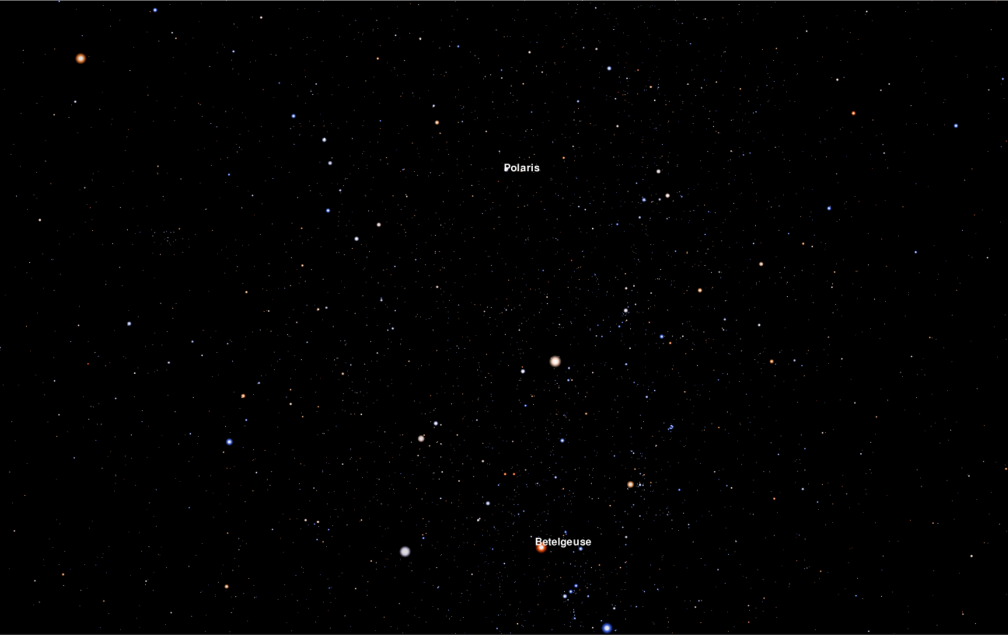
Figure 4.1: Stereographic Projection of stars in the Bright Star Catalog as of 01/01/2000 at 00:00

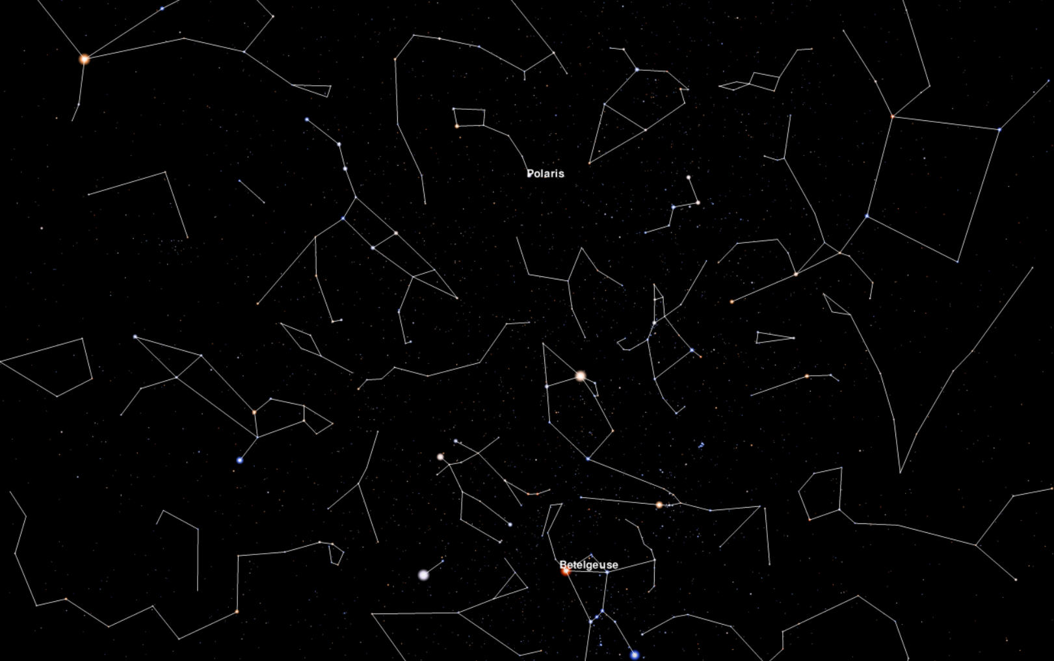
Figure 4.2: Stereographic Projection with Constellation Lines on

5.0 Converting between Galactic, Cartesian and Equatorial star coordinate system with Astropy and testing the performance.

5.1 Coordinate Systems

In the realm of astronomy, precise location tracking of celestial objects across various coordinate systems is fundamental. The galactic coordinate system, aligned with the Milky Way, and the equatorial coordinate system, aligned with Earth's equator, are extensively used for different observational needs. The transformation between these systems is facilitated by Astropy, a Python library designed for astronomy, which provides robust tools to handle such conversions accurately.

5.2 Galactic Coordinate System

5.2.1 Galactic Longitude (l)

- Definition: Galactic longitude is the angle measured eastward along the galactic plane from the Galactic Center. The Galactic Center, located in the direction of the constellation Sagittarius, serves as the zero point of galactic longitude.
- Measurement: Longitude in the galactic coordinate system is expressed in degrees, ranging from 0° to 360°. A longitude of 0° points directly toward the Galactic Center, while longitudes increase in the direction of the galaxy’s rotation, moving toward the galactic anti-center at 180°, which lies in the direction of the constellation Orion.

5.2.2 Galactic Latitude (b)

- Definition: Galactic latitude measures the angle above or below the galactic plane. This measurement is perpendicular to the line formed by the galactic longitude and provides a sense of how far an object is located from the central disk of the Milky Way.
- Measurement: Latitude is also measured in degrees, where 0° is on the galactic plane itself. Positive values (up to +90°) indicate positions north of the galactic plane, toward the north galactic pole in the direction of the constellation Coma Berenices. Negative values (down to -90°) indicate positions south of the galactic plane, toward the south galactic pole in the direction of the constellation Sculptor.

5.3 Cartesian Coordinate System

In astronomy, Cartesian coordinates provide a three-dimensional representation of space, where each point is determined by its x, y, and z values relative to a defined origin. This system is often used to simplify the computations involved in transformations between different celestial coordinate frames because it doesn't require dealing with angular measurements directly and allows for the use of linear algebra techniques.

5.3.1 X-Axis:
- Orientation: The x-axis originates from the Sun and extends through the galactic plane toward the galactic center. This axis points toward the center of the Milky Way Galaxy.
- Representation: In galactic coordinates, this axis is significant as it aligns with the major structural features of the galaxy, such as the densest part of the galactic disk and the central bulge where a supermassive black hole resides (Sagittarius A*).

5.3.2 Y-Axis:
- Orientation: The y-axis is also in the galactic plane but perpendicular to the x-axis. It points in the direction of galactic rotation, leading away from the Sun towards the outer edge of the galaxy.
- Representation: This axis helps define the direction of galactic rotation and is essential for understanding the dynamics of the Milky Way, including the motion of stars and other objects within the disk.

5.3.3 Z-Axis:
- Orientation: The z-axis is perpendicular to the galactic plane, extending out of the plane.
- Positive and Negative Directions: Positive values on the z-axis point toward the north galactic pole, while negative values point toward the south galactic pole.
- Representation: This axis is crucial for studying phenomena above and below the galactic disk, such as the distribution of globular clusters, the halo of the galaxy, and interactions with nearby galaxies and the intergalactic medium.

5.3.4 Significance of Each Axis
- X-Axis (toward the galactic center): Understanding phenomena associated with the dense core of the galaxy, including the dynamics around the central black hole, the structure of the inner spiral arms, and central starburst activities.
- Y-Axis (along the direction of galactic rotation): Crucial for analyzing the overall rotational dynamics of the galaxy, understanding differential rotation within the galaxy, and studying the distribution and movement of arms and molecular clouds.
- Z-Axis (perpendicular to the galactic plane): Important for investigating the vertical structure and thickness of the galactic disk, the halo component, and any extraplanar phenomena such as galactic fountains or interactions with satellite galaxies.

5.4 Equatorial Coordinate System

The equatorial coordinate system is a celestial coordinate system that is widely used to specify the positions of celestial objects. It is closely aligned with the Earth's rotation axis and equator, making it extremely useful for locating objects in the sky as seen from Earth. Here's a detailed look at the two main components of the equatorial system:

5.4.1 Right Ascension (RA)

- Definition: Right Ascension (RA) is the celestial equivalent of terrestrial longitude. However, unlike longitude, which is measured in degrees, RA is measured in time units: hours, minutes, and seconds. This measurement reflects the Earth's rotation in time, with 24 hours representing a full 360-degree rotation of the Earth.
- Measurement: RA is measured eastward from the vernal equinox. The vernal equinox, also known as the First Point of Aries, is the point on the celestial sphere where the Sun crosses the celestial equator from south to north at the March equinox. RA ranges from 0 to 24 hours, where each hour corresponds to 15 degrees of arc (360 degrees/24 hours).
- Usage: RA coordinates are used in conjunction with Declination to pinpoint the location of a celestial body in the sky. For instance, an RA of 5 hours means the object is located 1/5th of the way along the celestial equator from the vernal equinox toward the east.

5.4.2 Declination (Dec)
- Definition: Declination (DEC) is the celestial equivalent of latitude. It measures the angle of a celestial object north or south of the celestial equator.
- Measurement: Declination is measured in degrees, minutes, and seconds. The celestial equator is at 0 degrees, and the declination increases up to +90 degrees toward the north celestial pole and decreases down to -90 degrees toward the south celestial pole.
- Usage: Declination allows astronomers to determine how far above or below the celestial equator a celestial body is located. An object with a declination of +20 degrees is located 20 degrees north of the celestial equator.

5.5 Signs of values of each axis in the Cartesian Coordinate system

In the galactic coordinate system, the signs of the Cartesian coordinates (x, y, z) depend on the values of the galactic longitude (l), latitude (b), and distance (d). The determination of whether these values are positive or negative is governed by the definitions of these coordinates and the ranges of longitude and latitude. Here’s how each can become negative:

5.5.1 When will the x value be negative?

5.5.1.1 Astronomical Explanation:

- The galactic coordinate system is centered on the Sun, with the Galactic center in the direction of (l = 0°, b = 0°). The x-axis extends from the Sun towards the Galactic center.
- The x value will be negative when the object is located in the half of the galaxy that is opposite the Galactic center from the Sun’s perspective, specifically in the directions spanning from l = 90° to 270°.

5.5.1.2 Mathematical Explanation:

- The x-coordinate is calculated as 𝑥=𝑑cos(𝑏)cos(𝑙)
- Given cos(𝑙) is negative when 90∘<𝑙<270∘90∘<l<270∘, x will be negative in this range because the cosine of longitude becomes negative.

5.5.1.3 Example:

- If 𝑙=180∘ (directly opposite the Galactic center) and 𝑏=0∘ with any positive distance 𝑑, then:
𝑥=𝑑cos(0∘)cos(180∘)= −𝑑
Hence, x is negative.

5.5.2 When will the y value be negative?

5.5.2.1 Astronomical Explanation:
- The y value becomes negative when the object is located in the galactic coordinates where the galactic longitude (l) causes the sine to be negative, which happens in the third and fourth quadrants (l = 180° to 360°).

5.5.2.2 Mathematical Explanation:
- The y-coordinate is 𝑦=𝑑cos(𝑏)sin(𝑙)
- The sine of longitude sin(𝑙) is negative when 180∘<𝑙<360∘.

5.5.2.3 Example:
- If 𝑙=270∘ and 𝑏=0∘ with any positive distance 𝑑, then:
𝑦=𝑑cos(0∘)sin(270∘)= −𝑑
Hence, y is negative.

5.5.3 When will the z value be negative?

5.5.3.1 Astronomical Explanation:

- The z value measures height above or below the galactic plane. The z value becomes negative when the object is below the galactic plane (south of the galactic equator).

5.5.3.2 Mathematical Explanation:

- The z-coordinate is 𝑧=𝑑sin(𝑏)
- The sine of latitude sin(𝑏) is negative when latitude 𝑏 is negative (𝑏<0∘).

5.5.3.3 Example:

- If 𝑏=−30∘ (below the galactic plane) and 𝑙l is any value with distance 𝑑=1, then:
𝑧=1sin(−30∘)≈−0.5
Thus, z is negative.
These examples illustrate how the signs of Cartesian coordinates relate to their positions in galactic coordinates and reflect their astronomical positions relative to the Galactic center and plane.

5.6 Coordinate Conversion

For the purpose of the project, the star Betelgeuse is considered. The star’s galactic coordinates, and its distance from the sun in parsecs are initialized in python
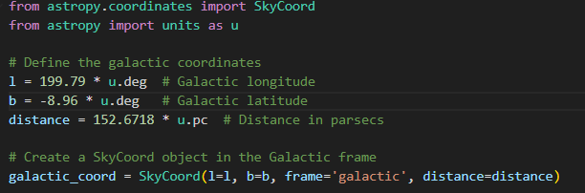
This setup demonstrates how Astropy integrates units and coordinate frames seamlessly, providing a robust platform for astrophysical calculations.

5.6.1 Conversion to Cartesian Coordinates

Astropy facilitates the conversion from spherical (galactic) coordinates to Cartesian coordinates, providing a basis for further transformations:
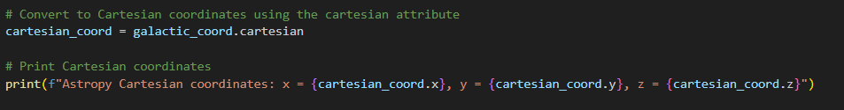
This step is critical as Cartesian coordinates simplify the application of geometric and algebraic operations necessary for subsequent coordinate frame transformations.

5.6.2 Transformation to Equatorial Coordinates

The Cartesian coordinates are transformed into the equatorial system (ICRS) using Astropy’s transformation capabilities:
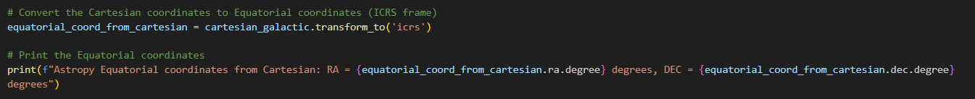
Astropy uses predefined rotation matrices that adhere to celestial coordinate transformation conventions, reflecting the alignment and tilt differences between the galactic plane and the celestial equator.

5.6.3 Reversibility and Verification

The accuracy and reversibility of conversions are verified by transforming the coordinates back to the original galactic system:
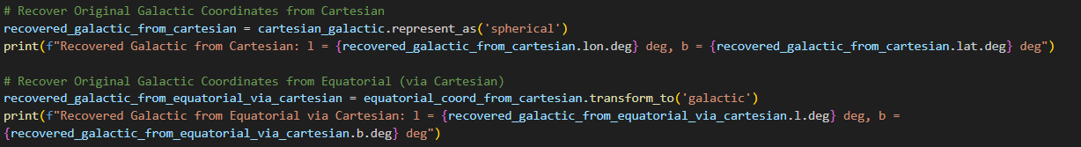
This step is essential to ensure that transformations can be reversed without loss of information, validating the integrity of the transformations for practical applications.

5.6.4 Direct Conversion and RA/DEC Conversion

Astropy also supports direct transformations between coordinate systems, simplifying the workflow for applications that frequently interchange between coordinate frames:

Additionally, the conversion of RA and DEC from traditional formats to decimal degrees is handled through a custom function, integrating these values into systems requiring decimal degrees:
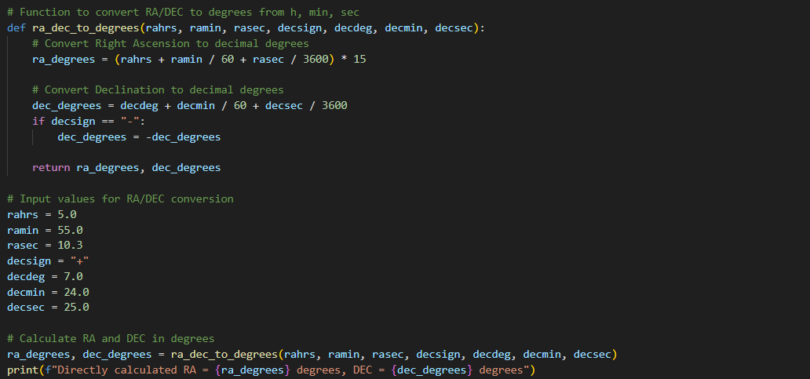
Finally, the full circle conversion is completed, and all the results are printed out as demonstrated in the figure below.
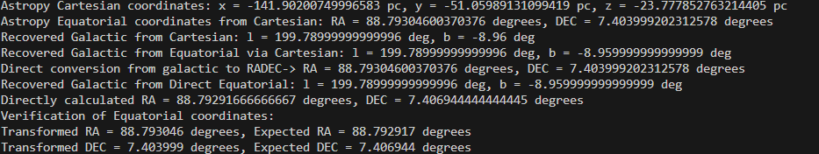

The study successfully demonstrates the effective use of Astropy for converting between galactic and equatorial coordinates, with a focus on the accuracy and reversibility of these transformations. The ability to reliably transform and verify celestial coordinates supports the integrity of astronomical data, which is crucial for the development of interactive applications such as stereographic projections and educational tools in astronomy. Through the integration of mathematical precision and the versatile tools provided by Astropy, this methodology offers a comprehensive framework for celestial coordinate transformations.

5.7 Discrepancies in Cartesian Coordinates when converted from Galactic frame and the Equatorial frame.

5.7.1 Transformation Discrepancies Overview

In the complex field of astrometry, the conversion of celestial coordinates across different systems invariably results in discrepancies due to the fundamental differences in these systems. For example, when the same celestial object is represented in both equatorial and Galactic coordinates, the derived Cartesian coordinates will differ. This section examines why and how these differences manifest by focusing on transformations using two primary systems: the equatorial coordinate system, centered around Earth's rotational axis, and the Galactic coordinate system, aligned with the Milky Way's plane.

5.7.2 Theoretical Foundations and Mathematical Representation

The equatorial coordinate system (RA/Dec) is based on the projection of Earth’s equatorial plane onto the celestial sphere, with Right Ascension (RA) measured from the vernal equinox and Declination (Dec) from the celestial equator. Conversely, the Galactic coordinate system (l/b) aligns with the Galactic plane, with longitude (l) originating at the Galactic center and latitude (b) measured from the Galactic equator upwards. The transformations between these systems entail rotational adjustments that can be mathematically expressed through transformation matrices.

5.7.3 Why Cartesian Coordinates Differ Between Coordinate Systems

The equatorial coordinate system (RA/Dec) and the Galactic coordinate system are oriented based on distinct celestial markers and planes:
- Equatorial System: This system is oriented relative to Earth's equator and rotational axis. The Right Ascension (RA) is analogous to longitude and is measured eastward along the celestial equator from the vernal equinox. The Declination (Dec) is analogous to latitude and is measured north or south from the celestial equator. This system's primary reference plane is the celestial equator, which is the projection of Earth's equator onto the celestial sphere.
- Galactic System: The reference plane for this system is the Galactic plane, which is aligned with the observable plane of the Milky Way Galaxy. The Galactic Longitude (l) starts at the Galactic center and measures along the Galactic plane, while the Galactic Latitude (b) measures angular distance above or below the Galactic plane.
To understand why coordinates differ, consider how each coordinate system describes the position of a point in 3D space:
- Spherical to Cartesian Conversion Formulas:
  - Equatorial:
𝑥=𝑟⋅cos(Dec)⋅cos(RA)
𝑦=𝑟⋅cos(Dec)⋅sin(RA)
𝑧=𝑟⋅sin(Dec)
Where r is the distance of the star in parsecs, Dec is the Declination of the star in degree, and RA is the right ascension of the star in Degrees.
  - Galactic:
𝑥=𝑟⋅cos(𝑏)⋅cos(𝑙)
𝑦=𝑟⋅cos(𝑏)⋅sin(𝑙)
𝑧=𝑟⋅sin(𝑏)
Where r is the distance of the star in parsecs, b is the galactic latitude in degrees and l is the galactic longitude in degrees.

5.7.4 Geometric Interpretation of Transformations

The above equations clearly demonstrate that even though the same star, such as Betelgeuse, is described in both systems, the actual Cartesian coordinates will differ because:
- Different Origins: RA/Dec is based on Earth's rotation and orbit around the Sun, meaning the origin and perspective are Earth-centered and aligned with Earth's axes. Conversely, Galactic coordinates take a more universal approach by aligning with the Galactic center, not Earth.
- Different Reference Planes: The celestial equator and the Galactic plane are inclined to each other at about 62.6 degrees, which means that the same physical point in space will have different coordinates under transformations associated with these tilted reference planes.
- Different Zero Points: RA is measured from the vernal equinox, while Galactic longitude is measured from the center of the Milky Way. This affects how angles (RA and l) are computed and interpreted in 3D space.
Therefore, the reason why the coordinates differ significantly across the two systems lies in the inherent geometrical and orientation differences of the reference planes used to define these systems. Transformations between these systems involve rotational adjustments that realign the coordinates according to their respective planes and origins, leading to different Cartesian coordinates for the same celestial object. These differences underline the importance of context and purpose when choosing a coordinate system for astronomical analyses.

5.7.5 Astropy Implementation to prove coordinate discrepancies.

To implement these transformations using Astropy, the following Python code snippet can be employed, demonstrating the conversion from equatorial to Galactic coordinates and subsequently to Cartesian coordinates for the star Betelgeuse, the attributes used here: Right Ascension, Declination and Distance are extracted from the Bright Star Catalog.
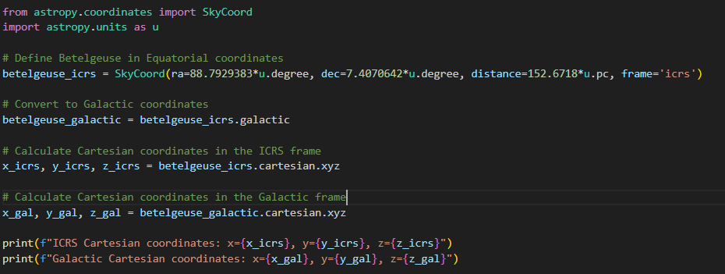

The discrepancies in the results are shown below.

5.8 Performance Testing

5.8.1 Objective
The objective of this performance test is to evaluate the scalability and efficiency of the Astropy methos in handling full-circle conversions between Galactic coordinates and Cartesian coordinates via Equatorial coordinates.

5.8.2 Data Preparation
Range of Data Sizes: The test iterates over data sizes ranging from 10,000 to 1,000,000 stars, increasing in steps of 100,000 stars. This broad range tests the methods' performance under both light and heavy computational loads.
Randomization of Input Data: For each iteration, a new set of random galactic coordinates and distances is generated. This ensures that each test is performed on unique data, thus preventing any caching mechanisms or optimization shortcuts from influencing the results. This randomness is crucial for a fair evaluation of the performance characteristics.

5.8.3 Tools and libraries used.

- Astropy: Chosen for its specialized celestial coordinate transformation capabilities, ensuring accuracy and adherence to astronomical standards.
- Matplotlib and Tqdm: Used for visualization and progress tracking, enhancing the clarity and usability of the test output.

5.8.4 Results
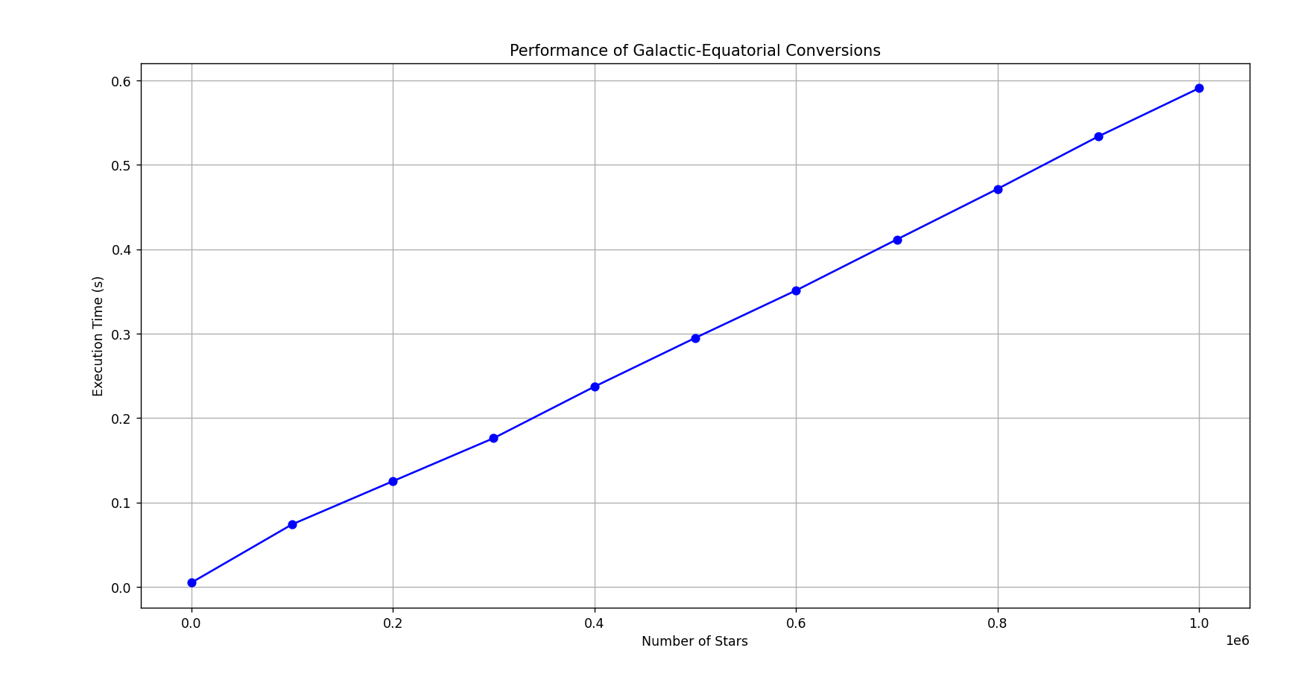
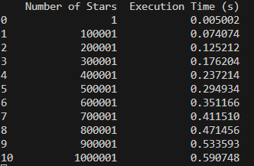

6.0 References

7.0 Appendices

To add on later
Performance comparison between numpy/astropy

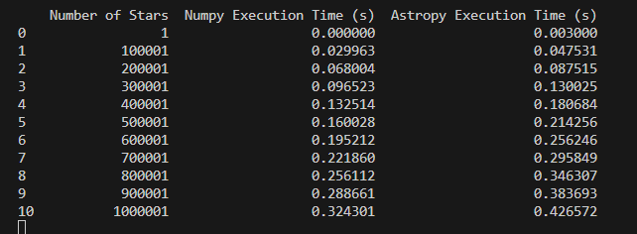

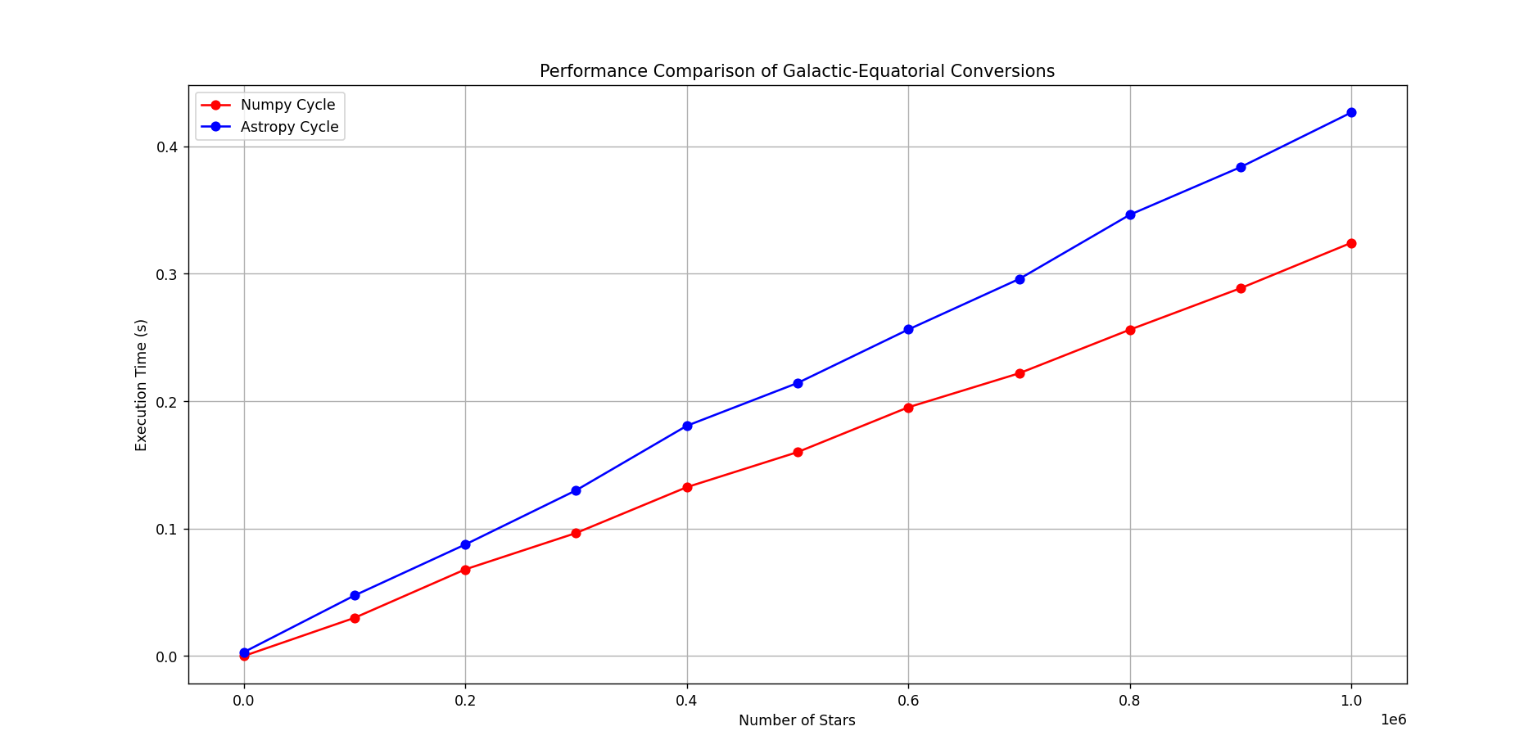

Conversion from Galactic – RADEC numpy
Mathematical Formulas and Constants
The transformation of galactic coordinates to equatorial coordinates involves specific astronomical constants and trigonometric calculations. Here’s a detailed breakdown of each component used in the function:
Constants
- RA_NGP (Right Ascension of the North Galactic Pole): 192.859508 degrees.
- DEC_NGP (Declination of the North Galactic Pole): 27.128336 degrees.
- L_NCP (Galactic Longitude of the North Celestial Pole): 122.931919 degrees.
These constants are critical as they define the fixed position of the North Galactic Pole and the angular distance from the Galactic Center to the North Celestial Pole in the equatorial coordinate frame. They are essential for aligning the two coordinate systems (galactic and equatorial).
Transformation Equations
The conversion from galactic coordinates (𝑙l,b) to equatorial coordinates (RA, DEC) uses the following trigonometric relations:
Declination (DEC):
Here, 𝛿 is the declination, 𝑏 is the galactic latitude, 𝛿𝑁𝐺𝑃​ is the declination of the North Galactic Pole, 𝑙 is the galactic longitude, and 𝐿𝑁𝐶𝑃 is the longitude of the North Celestial Pole.

Right Ascension (RA):
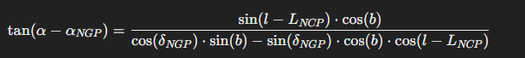
α represents the right ascension, and 𝛼𝑁𝐺𝑃​ represents the right ascension of the North Galactic Pole.

Implementation in NumPy
The implementation of this transformation using NumPy involves the following steps:
Conversion of angles from degrees to radians: NumPy provides efficient functions for converting degrees to radians, which is necessary for trigonometric calculations.
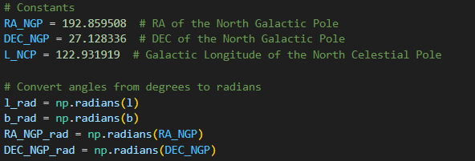
Calculation of DEC using sine: NumPy's np.sin and np.cos functions are used to compute the sine and cosine values required for calculating the declination.
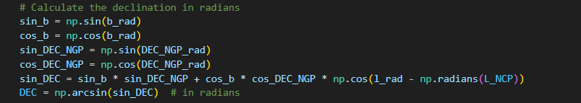
Calculation of RA using arctan2: The np.arctan2 function computes the arc tangent of two numbers, accounting for the quadrant of the result, which is essential for obtaining the correct RA.
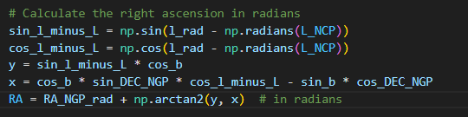

Final conversion to degrees and adjustment: The results for RA are adjusted by subtracting 180 degrees and then using modulo 360 to ensure the RA remains within a 0-360 degree range. This step is crucial for aligning the RA with the standard equatorial coordinate frame.

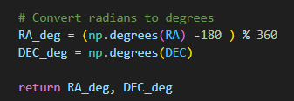

Explanation of the -180 Degree Adjustment
The adjustment of subtracting 180 degrees from the calculated right ascension in the final step of the conversion is crucial. This adjustment is necessary due to the orientation of the galactic coordinate system relative to the equatorial system:
- The galactic longitude 𝑙 is measured from the Galactic Center, which, in equatorial coordinates, is not aligned with the zero-point used in right ascension (the vernal equinox).
- By subtracting 180 degrees, we effectively re-orient the coordinate system, ensuring that the transformed RA values correctly align with the standard astronomical frame used for right ascension, which is centered around the vernal equinox. This adjustment ensures consistency with the universally accepted conventions for celestial coordinates.

Convert from Galactic -> Cartesian
Galactic to Cartesian Conversion
The transformation from galactic to Cartesian coordinates involves projecting galactic coordinates (longitude, latitude, and distance) onto a three-dimensional Cartesian coordinate system. This process is particularly useful in computational astrophysics for simplifying calculations involving distances and positions of celestial objects.
Formula and Implementation:
- Input Parameters:
  - l: Galactic longitude in degrees.
  - b: Galactic latitude in degrees.
  - d: Distance from the observer to the celestial object.
Conversion to Radians: For trigonometric calculations, it's necessary to convert angles from degrees to radians because trigonometric functions in most programming languages, including Python, operate in radians.
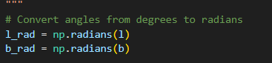
Calculating Cartesian Coordinates: The Cartesian coordinates (x, y, z) can be derived from spherical coordinates (d, b, l) using the following equations:
𝑥=𝑑⋅cos(𝑏)⋅cos(𝑙)
𝑦=𝑑⋅cos(𝑏)⋅sin(𝑙)
𝑧=𝑑⋅sin(𝑏)
These equations project the spherical coordinates onto a 3D Cartesian plane, where:
- x is the distance projected onto the galactic plane and along the galactic longitude.
- y is the orthogonal projection on the galactic plane.
- z is the height above or below the galactic plane, depending on the latitude.
Implementation in NumPy leverages the efficient computation of trigonometric functions directly applied to array operations, which is crucial for processing large datasets typically encountered in astronomy.
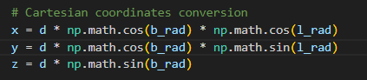

Cartesian -> Galactic
Cartesian to Galactic Conversion
The reverse transformation from Cartesian to galactic coordinates involves determining the galactic longitude, latitude, and distance from Cartesian coordinates. This is essential when the position of a celestial object is known in a 3D space and needs to be expressed in a galactic frame for astronomical analysis or visualization.
Formula and Implementation:
Input Parameters:
  - x, y, z: Cartesian coordinates.
Calculating Distance: The radial distance 𝑑d from the origin to the point (𝑥,𝑦,𝑧) in space is calculated using the Pythagorean theorem extended to three dimensions:
𝑑=sqrt(𝑥²+𝑦²+𝑧² )
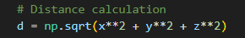
Deriving Galactic Coordinates:
Galactic Latitude (b) is calculated using the inverse sine function, where 𝑧/𝑑 represents the sine of the latitude:
𝑏=arcsin(𝑧/𝑑)
Galactic Longitude (l) is derived from the arctangent of 𝑦/𝑥y/x, adjusted for the correct quadrant with the two-argument arctangent:
𝑙=arctan2(𝑦,𝑥)
These calculations ensure the longitude and latitude are derived accurately based on the position in the Cartesian system.
Conversion back to degrees ensures the longitude and latitude are in the conventional angular format used in galactic coordinates.
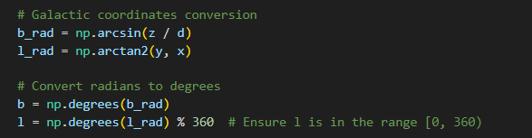

Ask Paul:
Can we merge the 2 full cycle conversions into 1 chapter and move performance testing to a next chapter?
Double confirm that the full cycle workflow is
Galactic -> 3D -> 3D mods -> Galactic -> RADEC
For the purpose of performance testing, we don’t include the 3D mods.

